Designing a high-availability (HA) client with server selection and authentication for reconnection ensures reliability and robustness in distributed systems. Here's how to design and implement these components:

Key Components
- Server Chooser:
  - Determines the best server to connect to during startup or reconnection.
  - Evaluates server health, latency, and load to make decisions.
- Authenticator:
  - Handles authentication with the chosen server.
  - Supports token-based or session-based mechanisms.
- Reconnection Logic:
  - Implements retry strategies and fallback mechanisms when the connection is lost.

1. Server Chooser
Responsibilities:
- Maintain a list of available servers.
- Periodically check server health and performance.
- Choose the optimal server based on defined criteria.
Implementation:
- Server List: A list of candidate servers fetched from a service discovery mechanism (e.g., DNS, Zookeeper, Consul).
- Health Check:
  - Ping each server or use a health-check API endpoint.
  - Measure response time and status (e.g., HTTP 200).
- Selection Criteria:
  - Prefer servers with low latency and high availability.
  - Optionally consider geographic proximity to the client.
Algorithm:
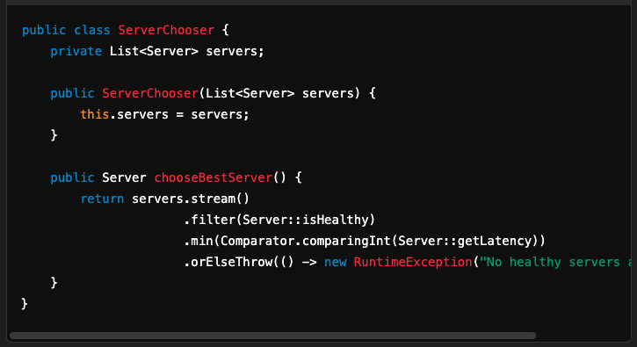

2. Authenticator
Responsibilities:
- Authenticate with the chosen server.
- Handle token refresh or re-authentication if required.
Implementation:
- Token-Based Authentication:
  - Use OAuth or JWT for secure access.
  - Store and reuse tokens until expiry.
- Session-Based Authentication:
  - Maintain a session cookie or ID.
- Fallback Mechanism:
  - Attempt reauthentication on failure.
Algorithm:
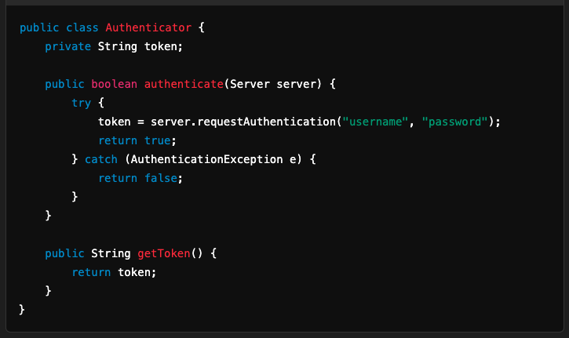

3. Reconnection Logic
Responsibilities:
- Detect disconnections and trigger reconnection.
- Implement backoff and retry strategies.
Implementation:
- Retry Strategies:
  - Exponential Backoff: Increase retry intervals exponentially.
  - Jitter: Add randomness to retry intervals to avoid cascading failures.

- Fallback to Alternate Servers:
  - On repeated failure, choose a new server using the ServerChooser.
- State Management:
  - Maintain the state of the connection and trigger appropriate actions.
Algorithm:
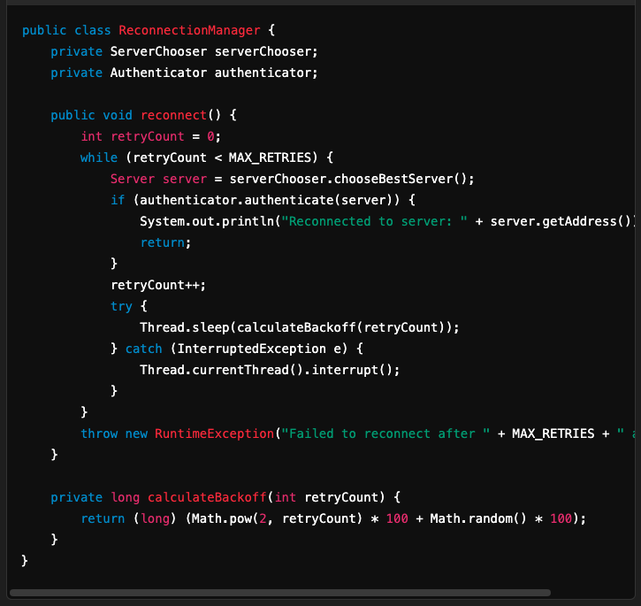

Workflow
- Initial Connection:
  - Use the ServerChooser to select the best server.
  - Authenticate with the chosen server using the Authenticator.
- Connection Monitoring:
  - Monitor the connection for failures (e.g., heartbeat, keep-alive).
- Reconnection:
  - On connection failure:
    - Retry connecting to the current server.
    - If retries fail, switch to an alternate server.
- Authentication Refresh:
  - Handle token expiry by refreshing or reauthenticating as needed.

High Availability Design
- Distributed Servers:
  - Deploy servers across regions for fault tolerance and low latency.
- Load Balancing:
  - Use a load balancer to distribute client requests across servers.
- Service Discovery:
  - Use tools like Zookeeper or Consul to dynamically fetch available servers.
- Failover:
  - Detect server failures and switch to healthy servers seamlessly.
- Health Monitoring:
  - Implement server health checks (e.g., CPU usage, memory, network latency).

Tools and Libraries
- Java Libraries:
  - Apache HttpClient, OkHttp for server communication.
  - Guava RateLimiter for retry logic.
- Cloud Services:
  - AWS Elastic Load Balancer (ELB), Google Cloud Load Balancer for server selection.
  - AWS Cognito, OAuth for authentication.

This design ensures reliable reconnection, minimizes downtime, and provides a seamless user experience in a high-availability environment.

